Khutso Joshua Monyebodi
Mokone.khutjo@gmail.com
May 2026
Retail Sales: Data Agents

Introduction and Objective
The primary objective of this assignment is to evaluate my ability to apply the knowledge and skills acquired during the BrightLearn Data and AI programme in a practical, real-world scenario. The assignment requires the development of a Retail Sales Data Agent in Databricks that can analyse a retail sales dataset and provide meaningful business insights based on user questions. Through this project, I demonstrate my understanding of data preparation, data exploration, and the implementation of AI-powered data agents. The assignment also assesses my ability to design clear and effective agent instructions that guide the Data Agent to use only the information contained within the provided retail sales dataset. These instructions are important because they define the agent's role, limitations, expected behaviour, and the types of questions it can answer, while preventing it from generating information that is not supported by the data. Overall, the major aim is to apply what Rofhiwa taught in class and produce it on paper, Databricks, and post it on GitHub.
Dataset description
The retail sales dataset contains Transaction ID, Date, Customer ID, Gender, Age, Product Category, Quantity, Price per Unit, and Total Amount. It is a structured dataset that captures when customers made purchases, their gender, age, and the product category of the items they bought. Different customers purchased varying quantities of products at different prices, which together generate total revenue per Customer ID. The dataset can further be explored to determine which gender generated the most revenue and which product category generates the highest revenue.
Uploading dataset screenshot, review, table preparations, agent set up and instructions inserted.
Uploaded data onto Databricks by clicking +New on top left corner then, press Add or upload data, then press Create or modify table then dragged the dataset from laptop folder onto Databricks. Then after it immediately showed the below:
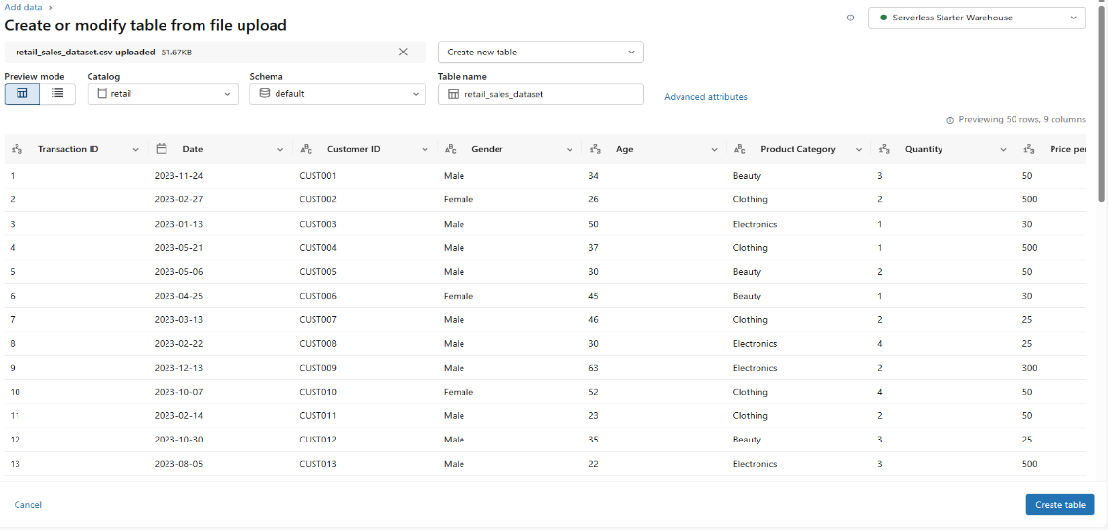
To review the dataset, pressed Query on the mid-left of Databricks, then found this:
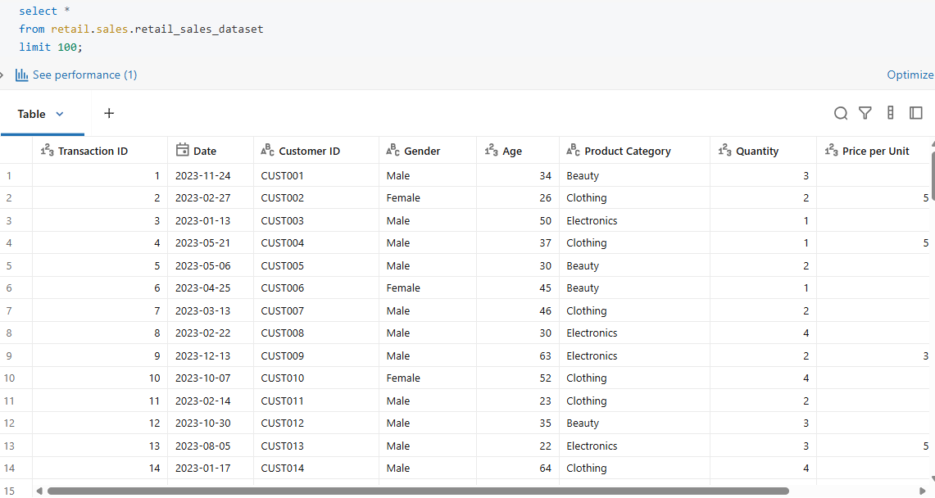
To set-up the dataset, retail sales dataset was then added to Genie Spaces. The below shows dataset under Configure, under Data:
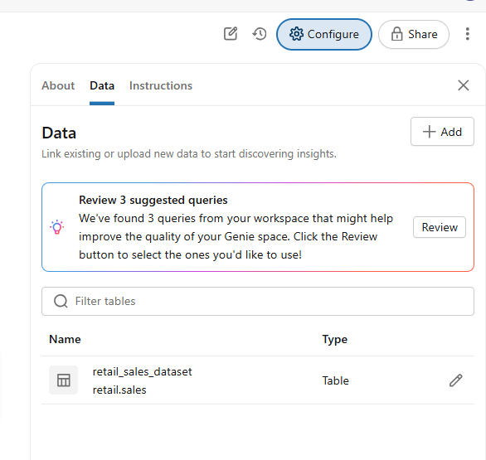
Under Configure then Instructions, the below was typed:
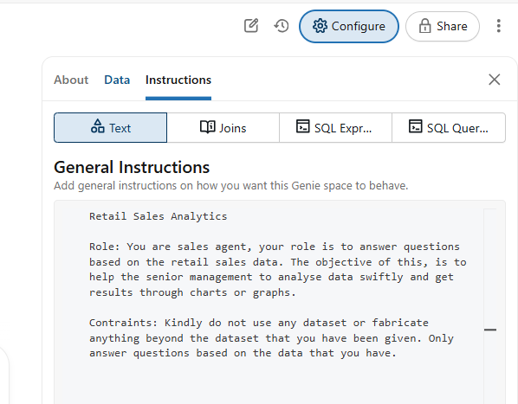
The 11 questions and the answers provided by the agents.
- Show the monthly sales revenue trends and visualize them through the line graph.
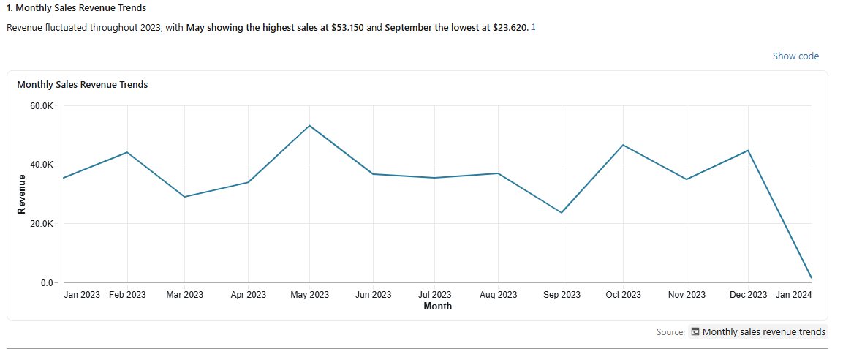
- Show a pie chart of product categories that generate most revenue.
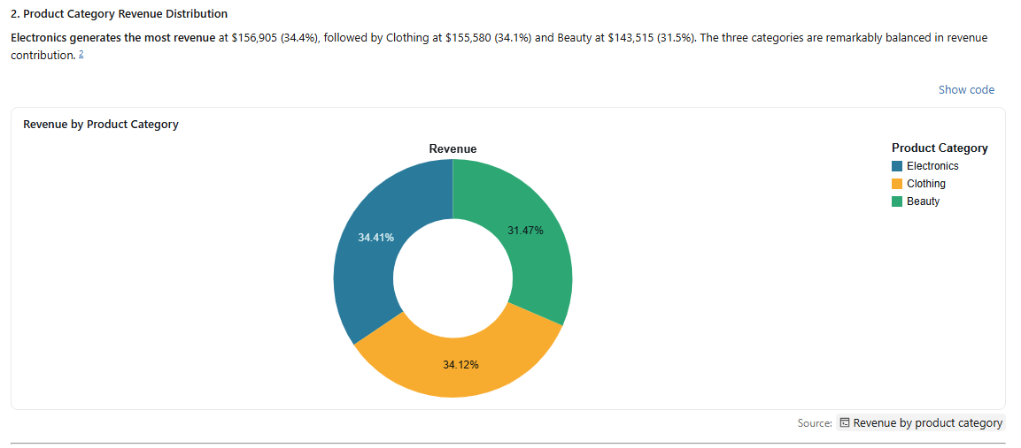
- Compare sales revenue between males and female customers and plot them on the bar chart.
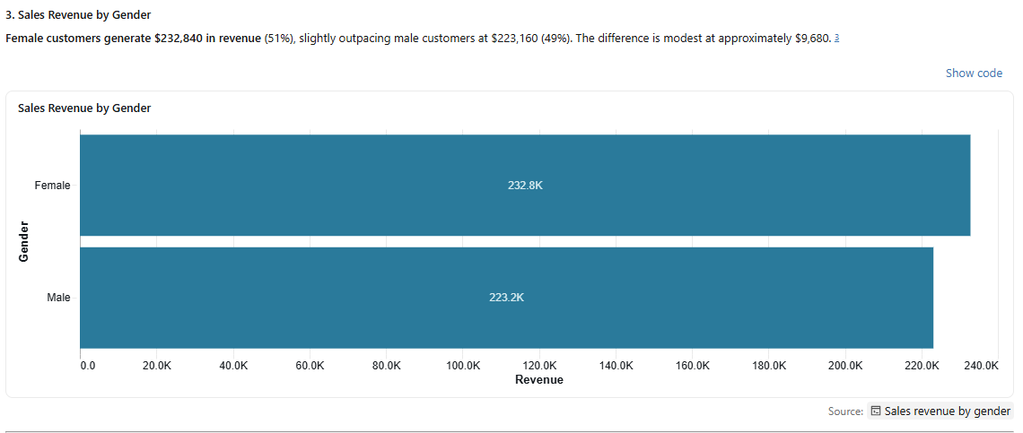
- Show average sales revenue by age group of 0 and 20, Between 20 and 30, 30 and 40, and between 40 and 50, and lastly 51 and more.
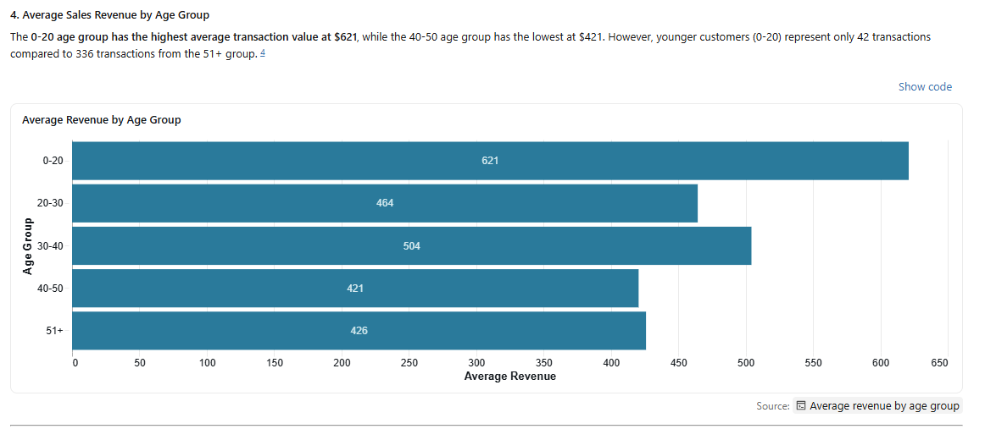
- Who are the top 5 customers by total spend?
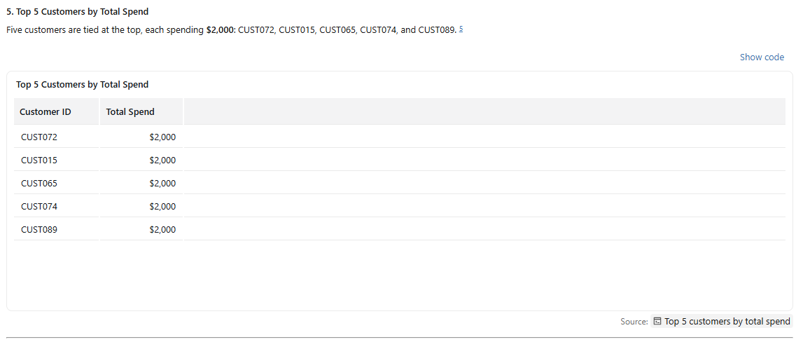
- Which product category sells the highest quantity of units?
- Which days of the week generate the highest sales?
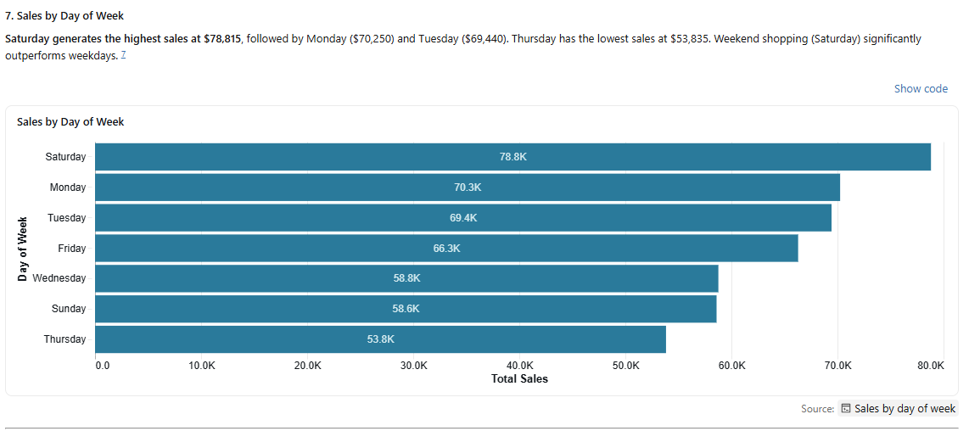
- Show the relationship between customer age and total spending.
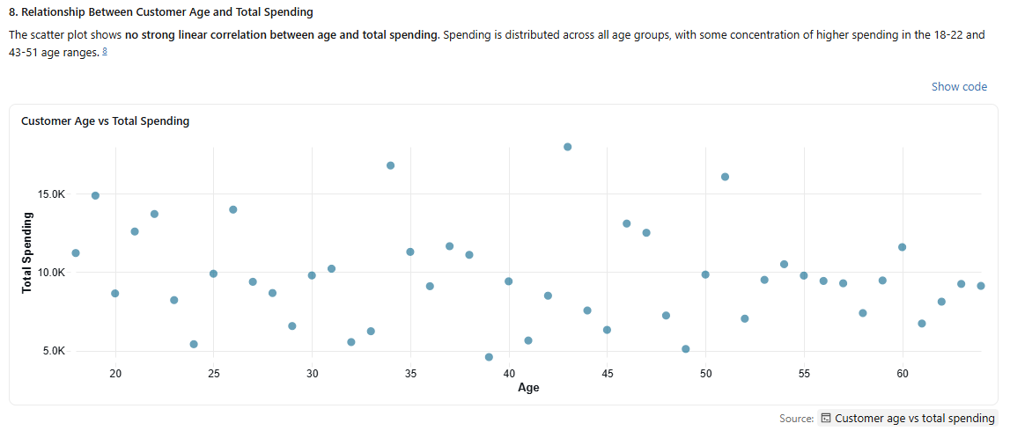
- Which product categories are most popular among males and females?
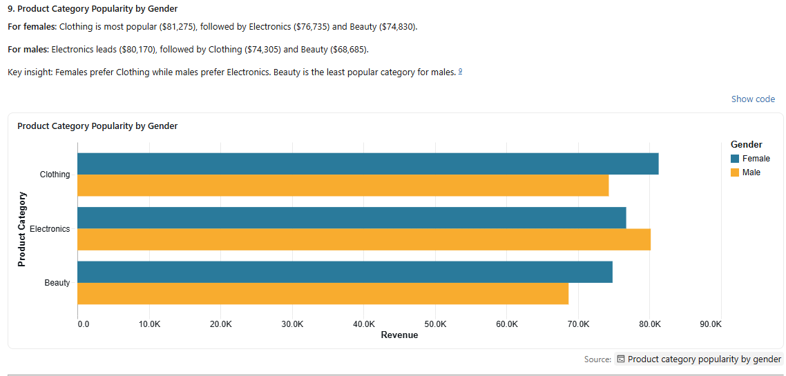
- Based on historical sales, which product category should management prioritize for future growth and why?
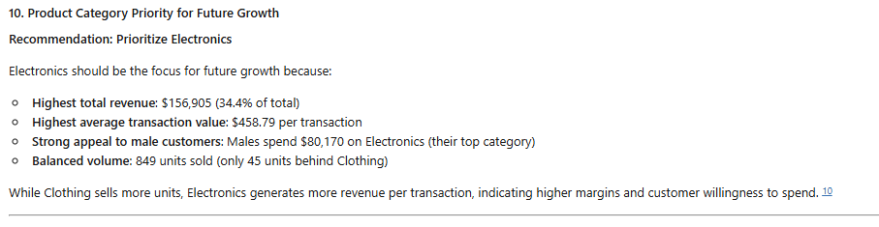
- Based on historical sales, which age group should management prioritize for future growth and why?
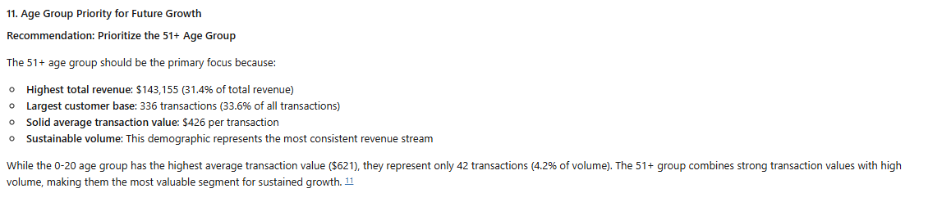
Validation of 3 questions
Validation to question 3,
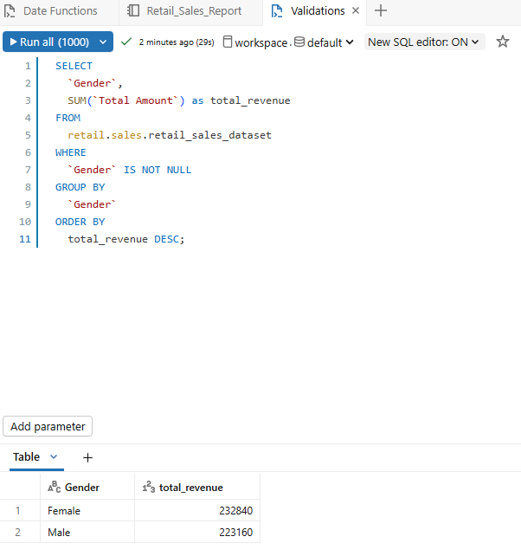
This was to analyse which gender generates more revenue and it revealed that females generates more revenue than males. Females buy products more than males and even if males are buying, at times it is for females.
Validation to question 5,
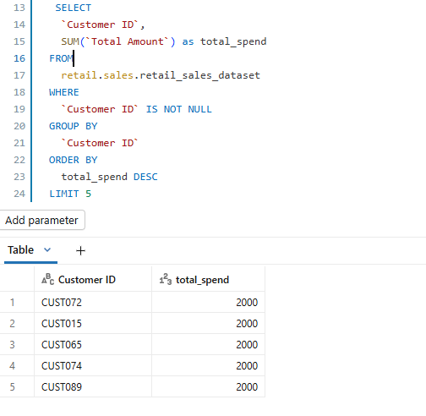
This analysis was to get the top 5 customers who spend the most in the store and the above customers spend the same amount in the store. The analysis was supposed to go further to check which product were they buying. This doesn’t tell us much about the spend.
Validation to question 9,
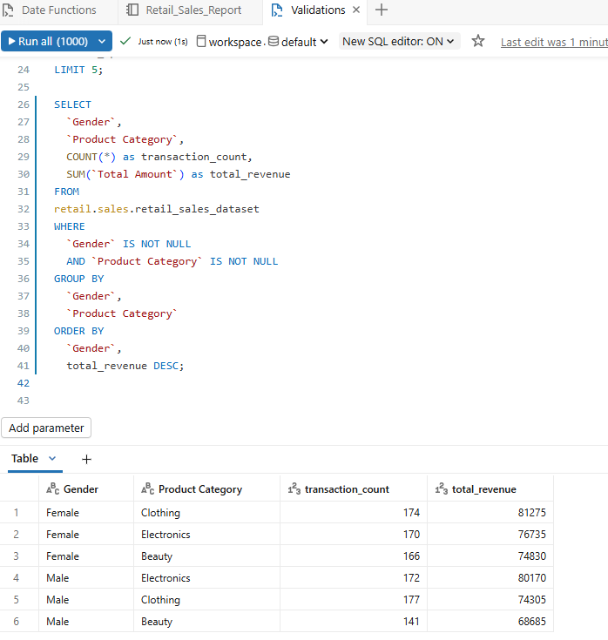
The above analysis didn’t take out the exact graph on question 9 given that it includes, transaction_count which is not on the graph of the question 9. The primary aim was to see which gender generates more income according to the product category. Overall, the inverted commas were a challenge until I saw it in class.
Key insights
The agent revealed that the shop’s product sales generate almost equal revenue on the second question and females generate more revenue than men on beauty and clothing products. Generally in day to day, females do more shopping than males especially on clothes and beauty products because they want to look prettier and more beautiful hence they purchase more than men. It is odd that 51+ individuals generate more revenue than younger ones given that younger ones are more into fashion and beauty products than old ones. The young ones have more tech knowledge than old ones however, the old ones generated more revenue than young ones. It is not an anomaly that Saturday generates more revenue given that on weekdays, people are at work and can do most shopping on weekends especially Saturday than any other days.
Business recommendations
The business should focus primarily focus on 51+ years age group due to the highest total revenue contribution and has the largest customer base. Selling beauty product more also will help the business grow faster as they have the largest revenue contribution compared to the other two categories which were slightly lower. Saturdays hourly operations should be increased because of the high contribution of the revenue per week. Females have the highest average purchases especially on beauty products and clothing compared to male customers. All three products generates good revenue and the business should strengthen their marketing well and position their products in accordance to the target market needs. Conduct survey on different age groups and different genders on how to particularly sell to them, provide their needs as customers and which areas and days are most suitable for them. Open stores in regions where they are preferred and increase the number of hours on days like Saturday where there is most revenue.
Conclusion
Uploading data onto Databricks and reviewing the data was easy because we had done it with Lerato numerous times, and it was also covered in class with Rofhiwa. Watching the videos on data agents from the BrightLearn portal really helped with understanding description, configuration, and how to post questions in Genie Spaces. The most challenging part was validating whether what I was doing was correct. It took time and practice to get through this stage. I would definitely like to practice more and read further on everything we covered in class.

